Guidelines on abstract format for submission to the XII Spanish-Portuguese Conference on Controlled Drug Delivery

X.Y. Presenting Author¹*, Z.V. Author¹, C.T. Author^{1;2} and H. Author²

¹Institute of Applied Science, Faculty of Science and Technology, University of the South Pacific, Private Bag, Laucala Campus, Suva, Fiji
²European Synchrotron Radiation Facility, B.P.220, F-38043 Grenoble Cedex, France

*e-mail: corresponding_author@usp.ac.fj

Abstracts must be written in English and the preferred length of the abstract is about 800 words. The Title (14 pt bold) should be no more than 180 characters in length. The name of the presenting author should appear first in the list of authors. The e-mail address of the presenting author is mandatory.
Size of the font used in the abstract text is 10 pt, whereas the font size in figures, legends and references are 9 pt. Please provide the Affiliations (9 pt italic) in a concise manner. Font type is Times New Roman.
Please do not include in the abstract more than one figure (see Figure 1). For best results, submit artworks in the actual size and do not resize it in the word processor.
Use of this template will be highly beneficial (already with the right margins), as the entire abstract (text, tables, and artworks) may be submitted in just one file, with the desired organization, thus expediting publication. Moreover, it will allow to determine whether their manuscript is within the one page limite.

The body of the abstract should include Introduction, Materials and Methods, Results and Discussion and Conclusions. References should be indicated by numbers in square brackets [1], [2], [3] etc. in the text and be given at the end of the abstract using 9 pt type.
There is enough space for approximately 800 words (4000 characters) of text in Times New Roman, font size 10 in a maximum area of one page DIN A4. Do NOT use a smaller font size. Use single spacing.

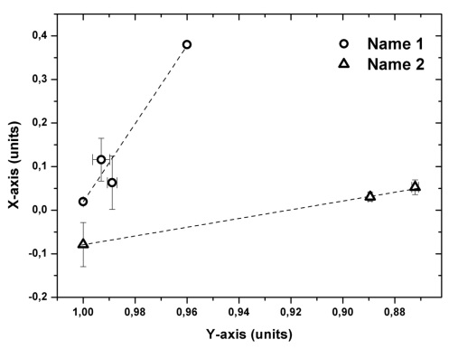
Figure 1. Figure title

Acknowledgments: This work was supported by ...

- M. Svandrlik, F. Parmigiani, Nat. Photonics 2014, 8, 82.
- S. V. Krivovichev, Angew. Chem. 2014, 53, 654.
- P. Murck, New age of synchrotron studies (Sun Editors, Honolulu 1891)

